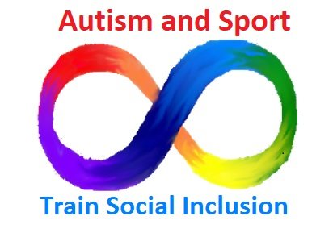 YOUR LOGO 
PROIECT “AUTISM AND SPORT : TRAIN SPORT INCLUSION”
YOUR ORGANIZATION
This questionnaire aims to collect the opinions and feelings of parents of autistic children on the subject of their possible involvement in sport. The goal is to bring the point of view of parents on this subject to trainers and operators, in order to ensure that inclusion activities in sport are also designed taking into account parents’ fears and expectations.
We believe it is important that separately both parents of the autistic person complete the questionnaire. In the (remote) case where there is more than one autistic child, we kindly ask you to complete a questionnaire for each of the children.

1) Parent completing the questionnaire
Mother Father Mother and Father together

2) Sex of the autistic son/daughter:
Male Female

3) Age Group of the autistic son/daughter:
< 8 years 8-14 years 15-19 years 20-30 years 31-40 Years > 41 years

4) Pathology description
Low-Functioning Autism High-Functioning Autism
Mental Disability Other psychiatric pathologies
Other:_____________________

5) What sporting activities your son/daughter currently does?
Group Activities
Football BasketBall Volleyball Other :________________
Individual Activities
Horse Riding Swimming Athletics Judo Other:________________

6) Sports activity can help your son/daughter from a social/relational point of view?
No Help 1 2 3 4 5 6 7 8 9 10 Very much

7) What results do you hope your son/daughter will achieve by playing sports with non-autistic peers?
Place in order of importance by marking 1 the most important, 2 the second most important, and so on
No Results
Fun
Physical Improvements
Social Improvements
Other:_____________

8) Do you have fears/concerns about your child's involvement in sporting activities?
No 1 2 3 4 5 6 7 8 9 10 Many

9) What fears influence your choice to have your child participate in sports with non-autistic peers?
Place in order of importance by marking 1 the most important, 2 the second most important, and so on
No Fear
The potentially negative behavior of non-autistic peers with my child
He/She could get hurt
He may not be able to handle the stress of the situation
Other:________________

10) What obstacles you have encountered in involving your child in sports activities?
Place in order of importance by marking 1 the most important, 2 the second most important, and so on
No Obstacles
Lack of time to include sports on my child's agenda
Lack of motivation on the part of my son
Distance from the sporting facilities/ Lack of sporting facilities that offers such possibility
Lack of information about it
Lack of operators who can adequately follow my son
Other:__________________________________

11) What was your experience (if there was one) of "integrated" sports activity for your child and what did you like?
(integrated sports activity = sports activities where autistic people interact with neuro-typical people)
__________________________________________________________________________________
__________________________________________________________________________________
__________________________________________________________________________________
__________________________________________________________________________________

12) In Order to promote the dissemination of social integration sporting events, from your point of view, which event would be best suited to you given your family situation and your child?
Place in order of importance by marking 1 the most important, 2 the second most important, and so on
Sport day in which different sporting activities are demonstrated
Seminars and informative events
Awareness-raising activities aimed at parents
Awareness-raising activities aimed directly at children
Other:____________________________________

13) The Autism and Sport project provides a training course on sport and autism aimed at social workers and volunteers, sports associations and relatives of autistic people.
In case you are interested, would you attend such training?
Yes No

Why? : (please express you main motivation for your answer)
_____________________________________________________________________________
_____________________________________________________________________________
_____________________________________________________________________________
_____________________________________________________________________________

Thank you for the time you have dedicated to us!

Return the filled questionnaire as soon as possible

